.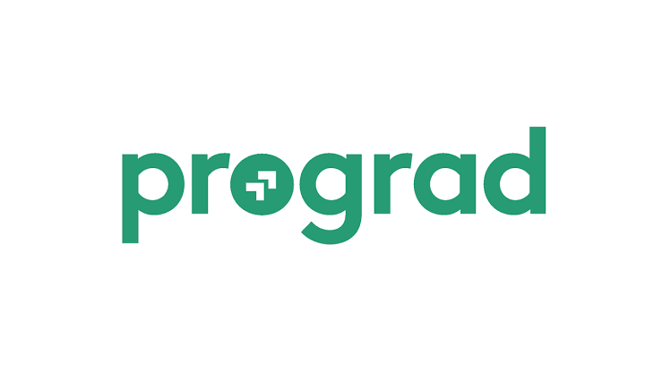

**We have 200 written images that we need you to convert to word document within 2 to 3 days**

**I hope you can do that?**

**IF YES**

**Project prize:3840£**

**We want the best on this So we'll be paying £3840.00 Please understand that we're paying this much because the intensity of the project**

**Kindly contact (@Progradinc) via telegram if you don't have the app you can download telegram app from your app store then you contact with (@progradinc), to get more informations for you to start your project immediately.**

**Click on the link below 4 direct to telegram**

**https://t.me/progradinc**

**Message him with this code : 699622**